2.3.1 Learning Methods – Tools Available with HEI

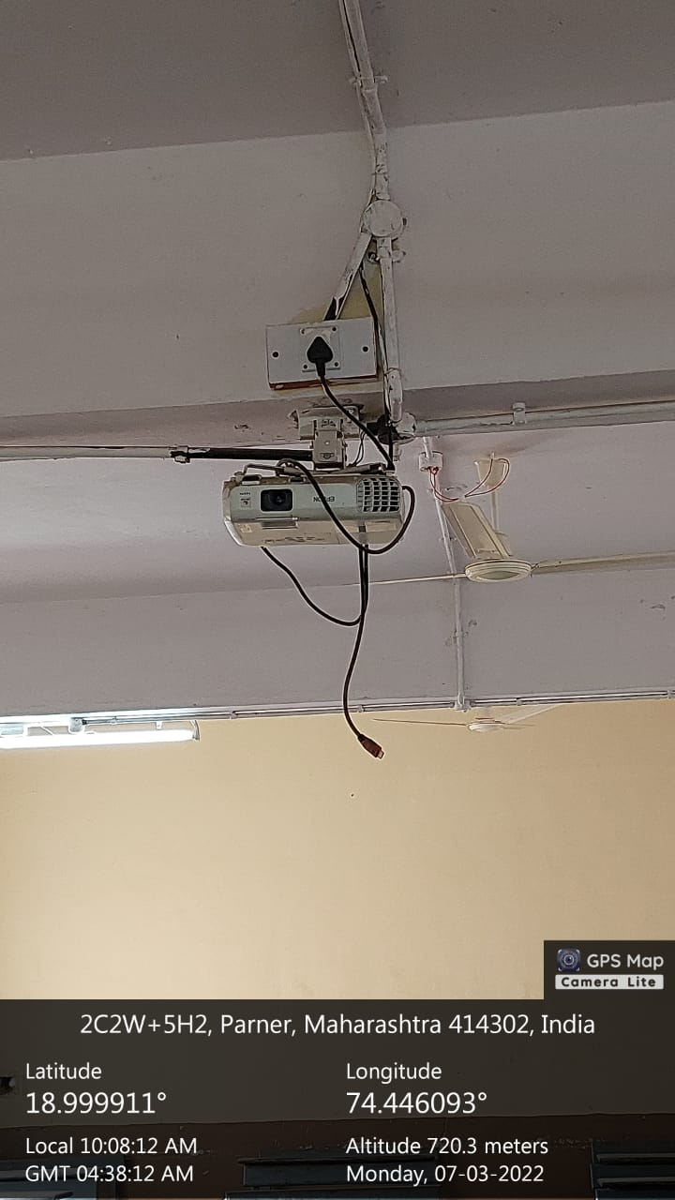 | 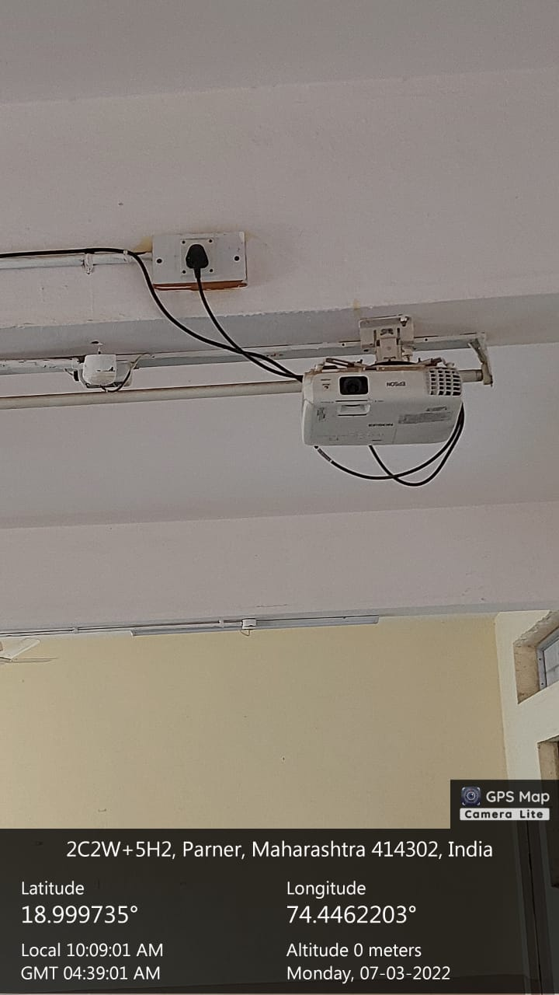
Science Building Classroom No. R-101 | Science Building Classroom No. R-102
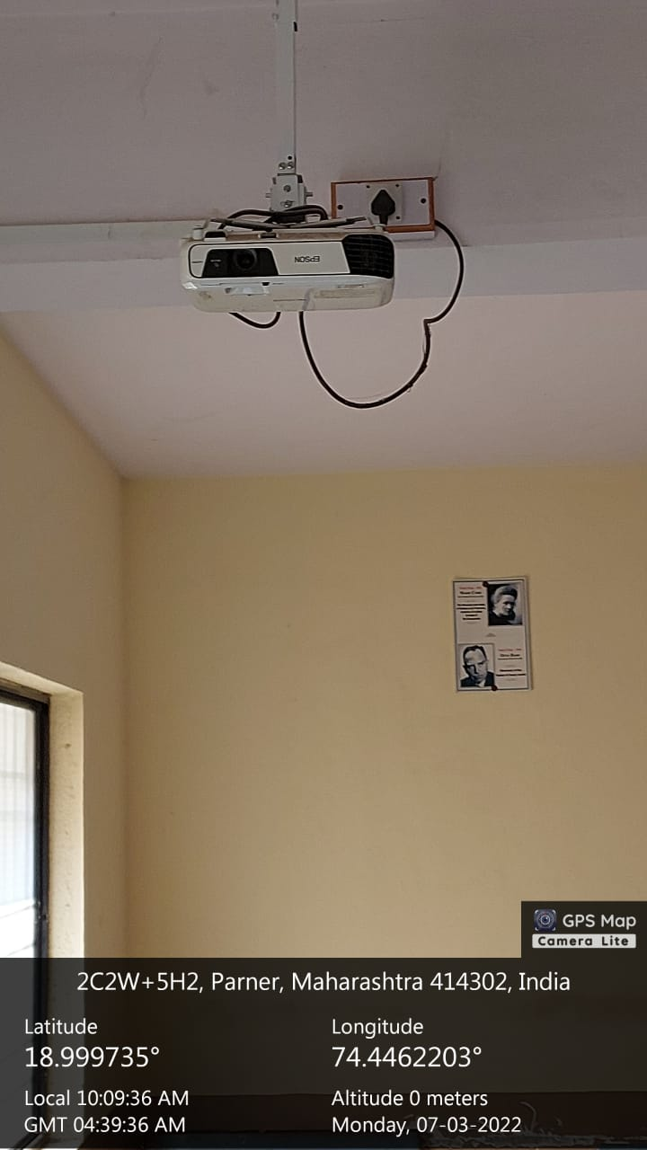 | 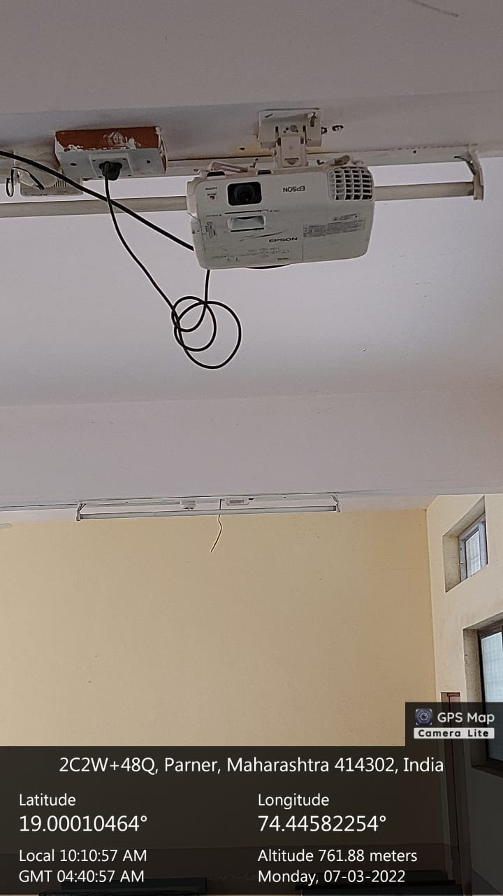
Science Building Classroom No. R-103 | Science Building Classroom No. R-201

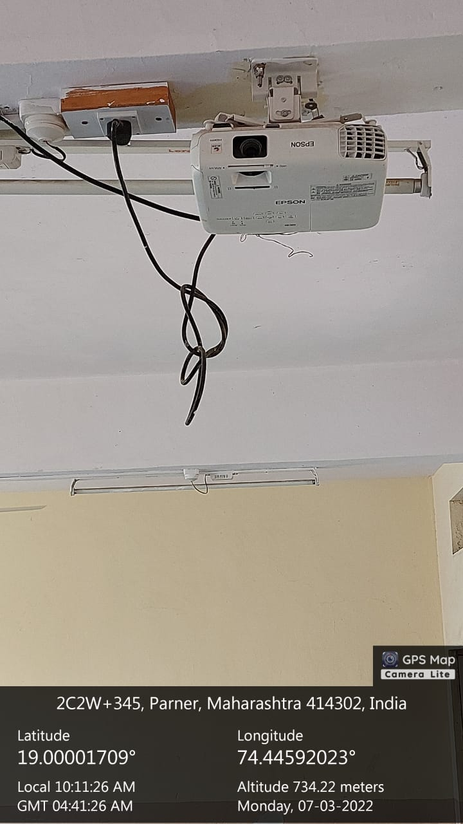 | 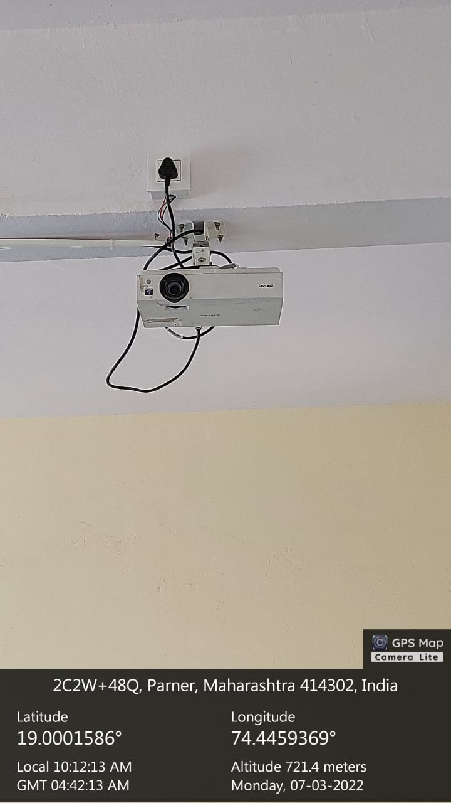
Science Building Classroom No. R-202 | Science Building Classroom No. R-203
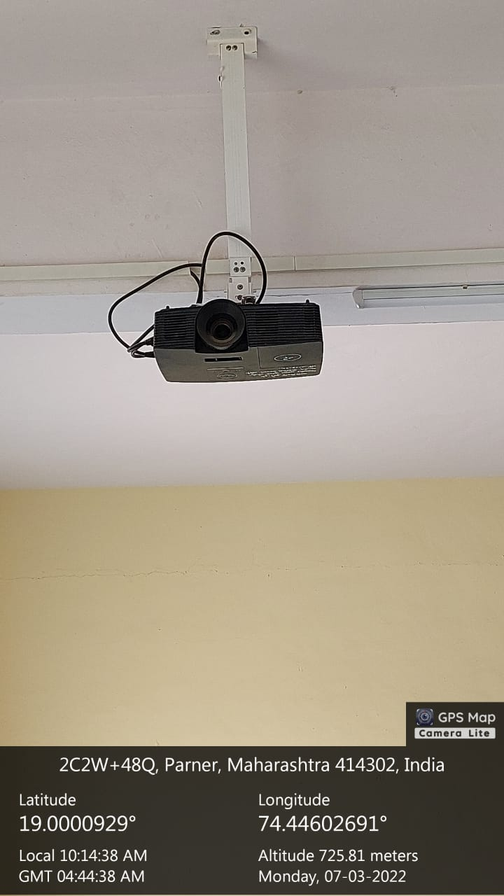 | 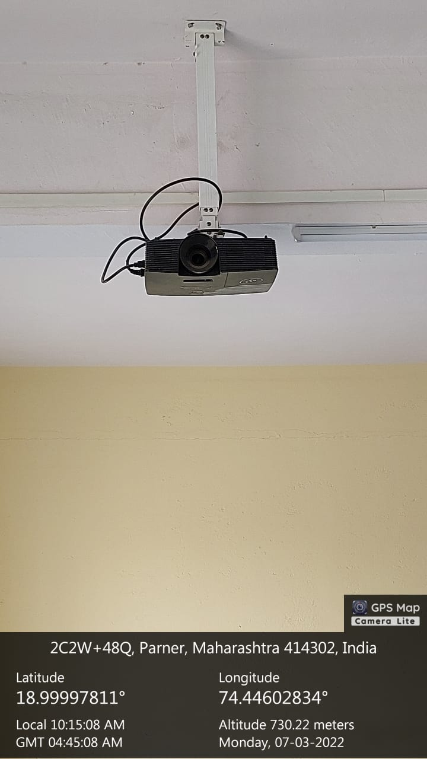
Science Building Classroom No. R-301 | Science Building Classroom No. R-302

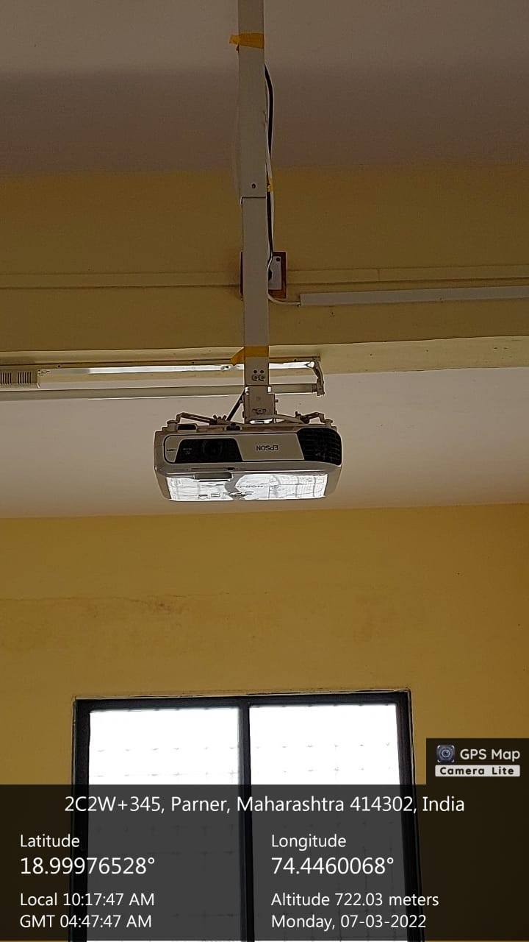 | 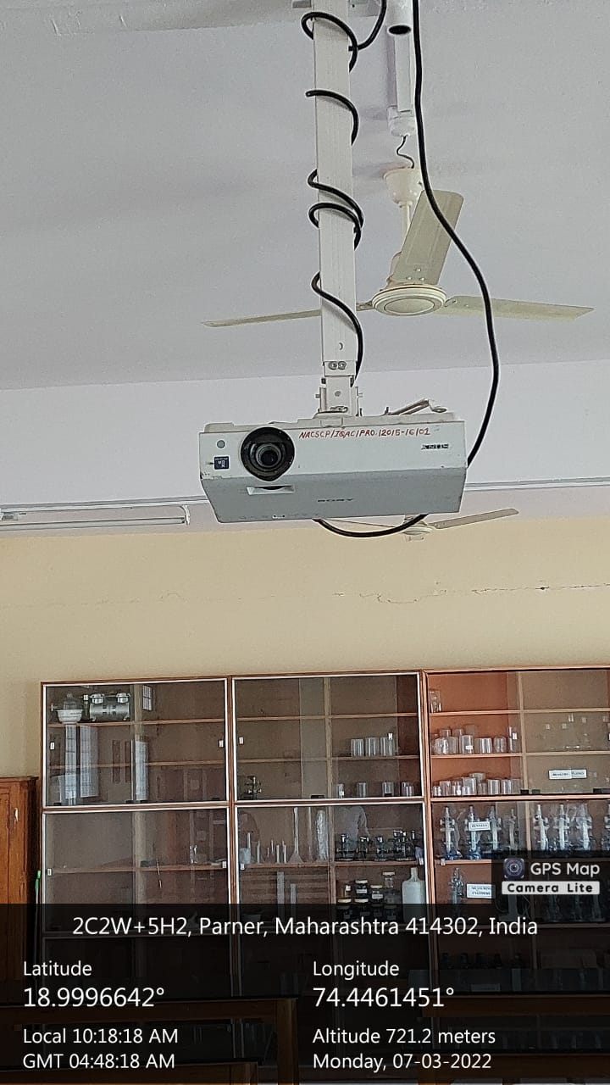
Science Building Skill Development Centre No. R-307 | Science Building Gen.Lab-II Botony No.  R-308
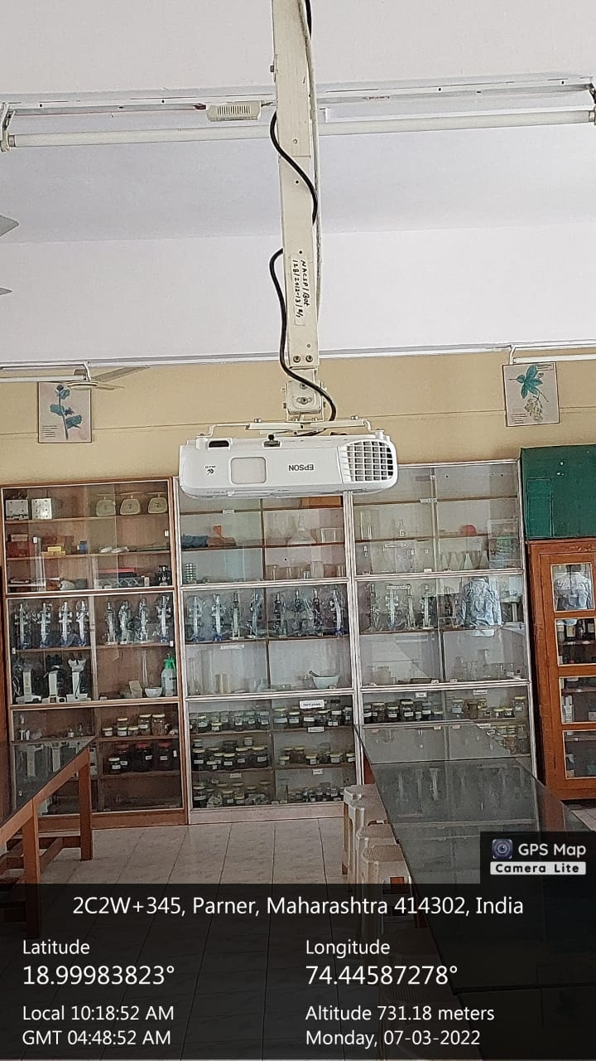 | 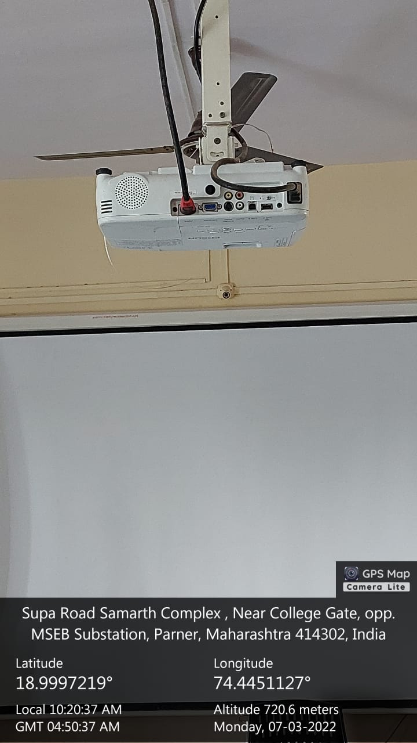
Science Building Gen.Lab-I No. R-309 | Science Building Zoo.Lab No. R-313

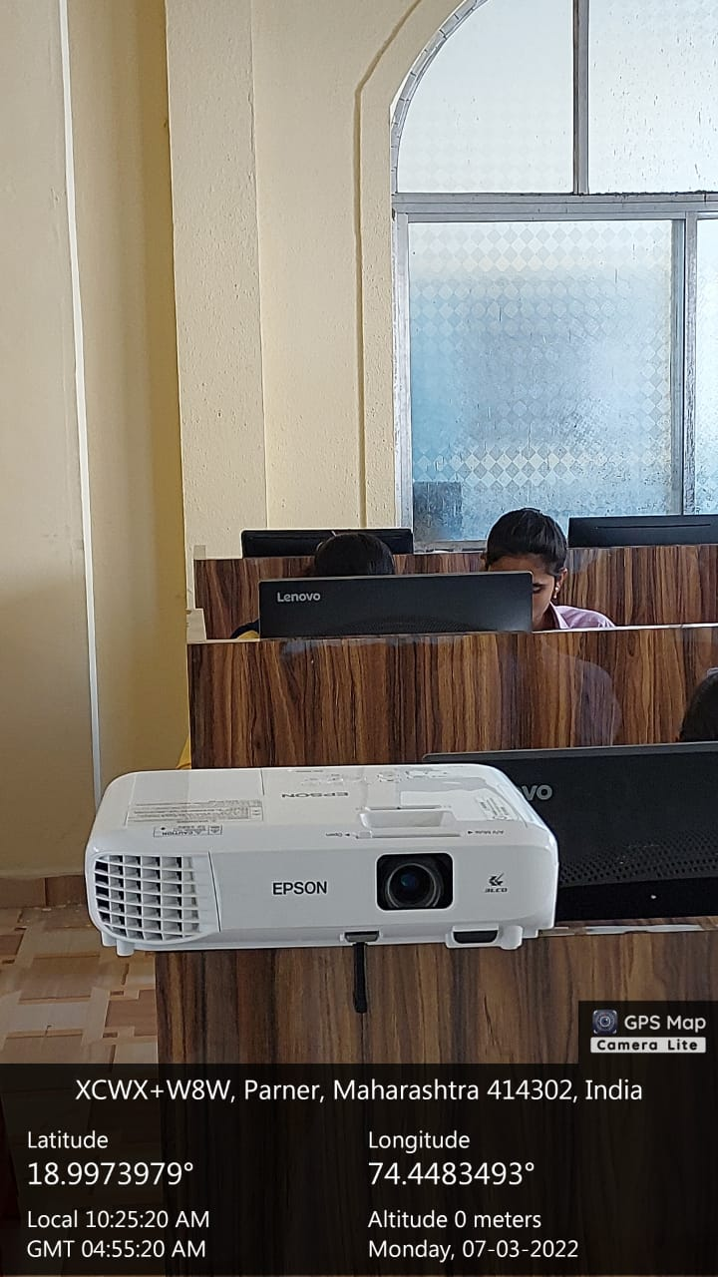 | 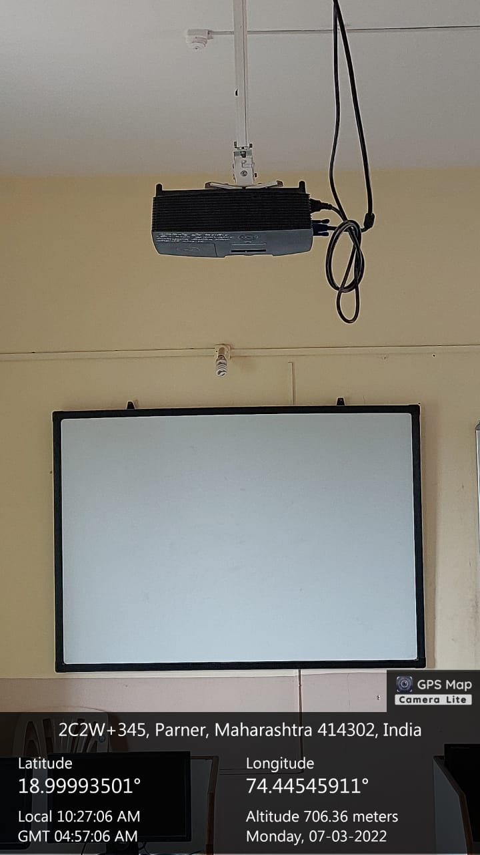
Science Building B.Voc Lab | Science Building Comp.Lab – II No. 209
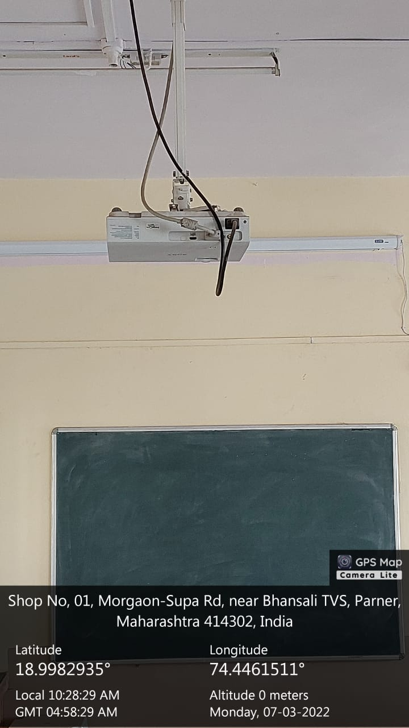 | 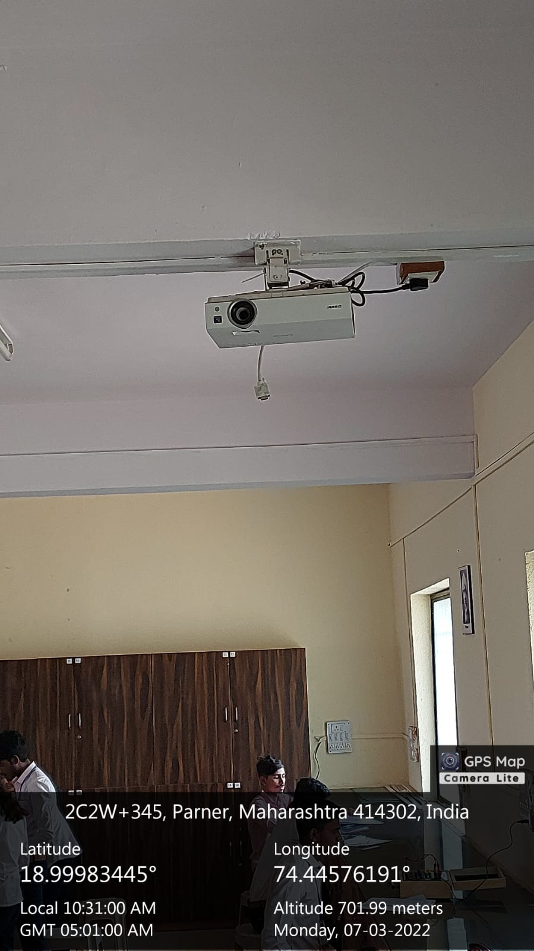
Science Building Gen.Lab Physics-I No. R-207 | Science Building Gen.Lab Physics-II No. R-205

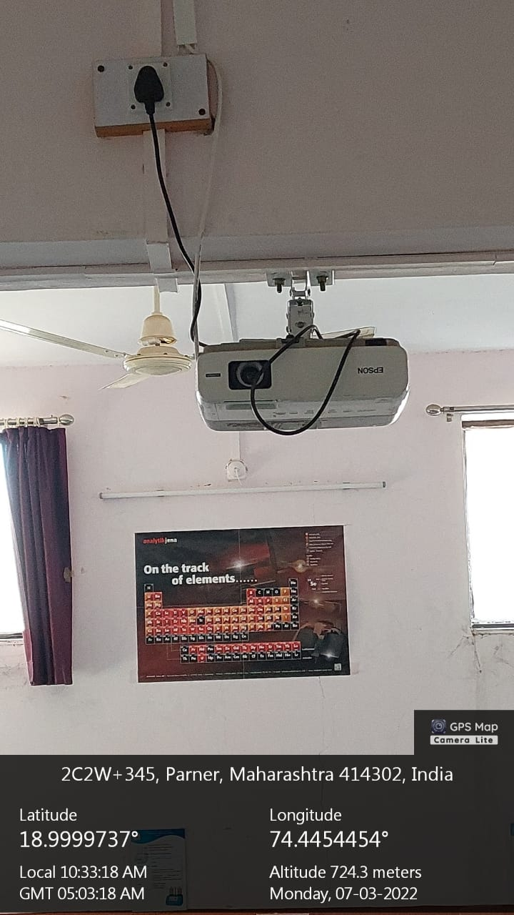 | 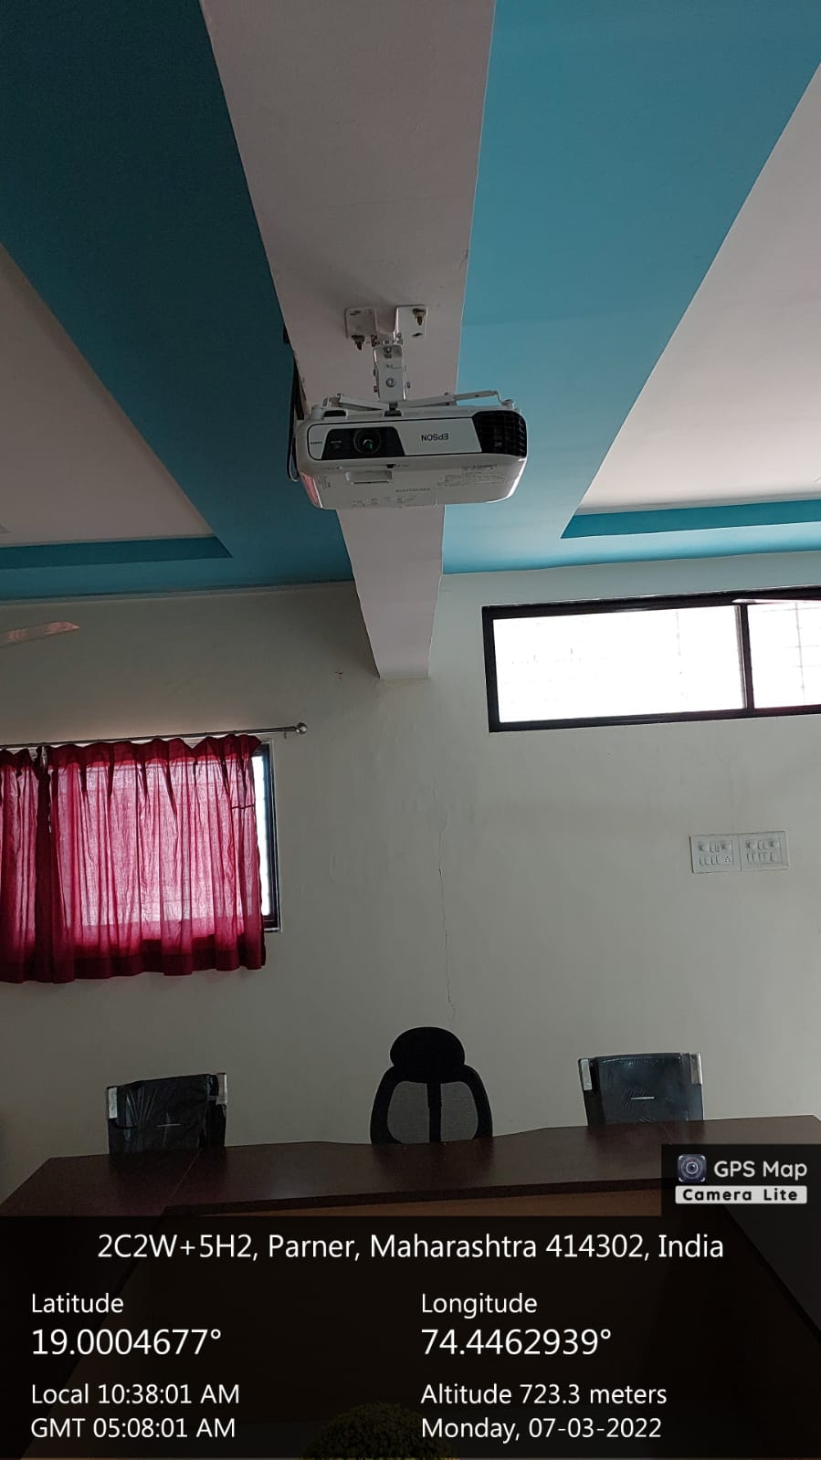
Science Building Chem.Research Lab No. R-117 | ADMIN Building IQAC No. R-103
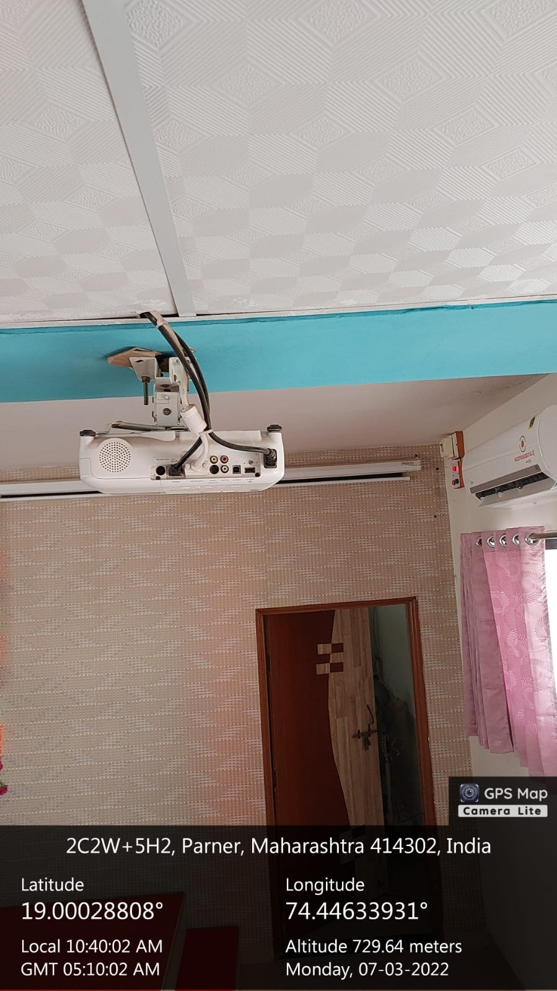 | 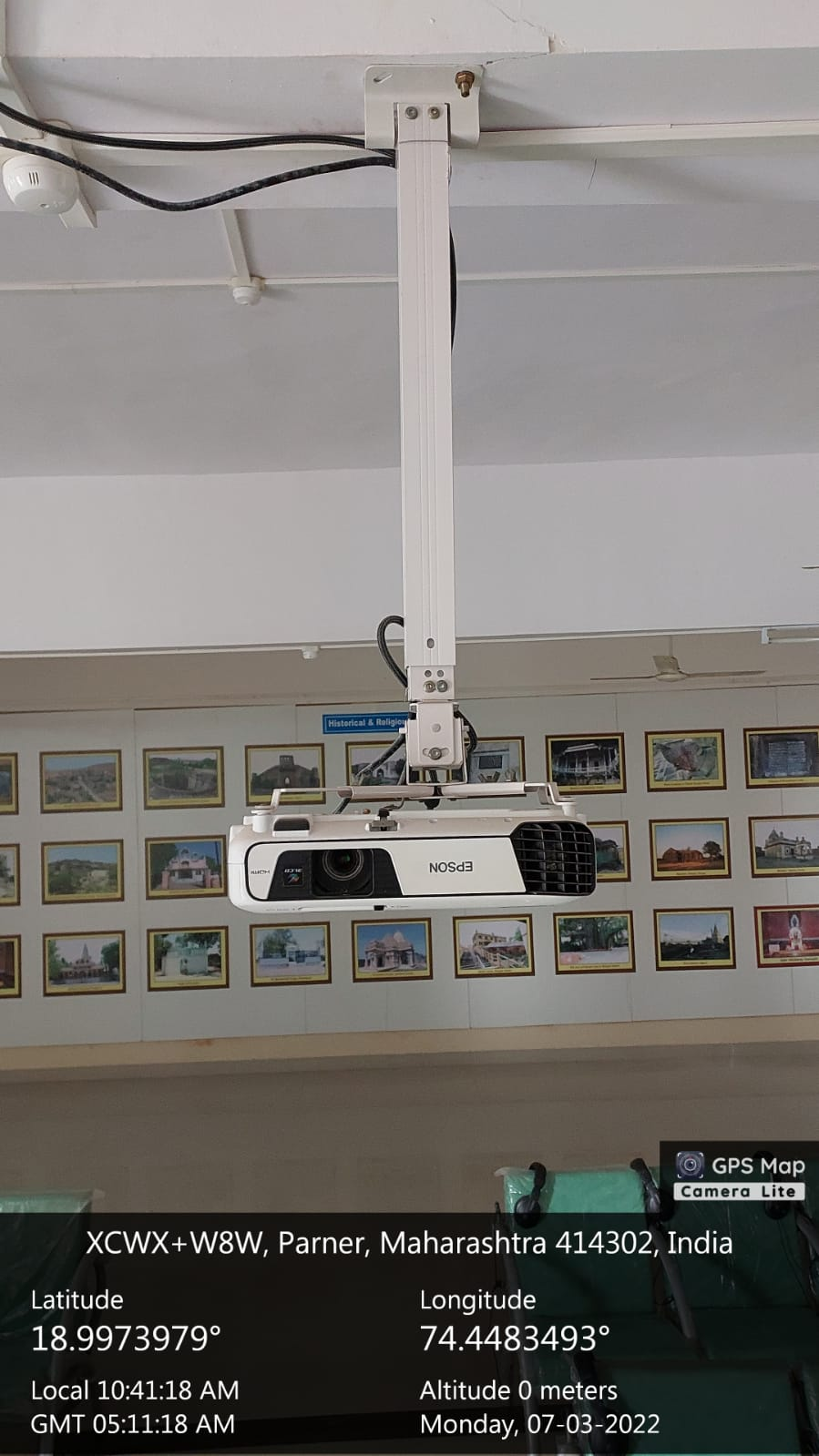
ADMIN Building Conference Hall | ADMIN Building Language Lab & Digital Museum

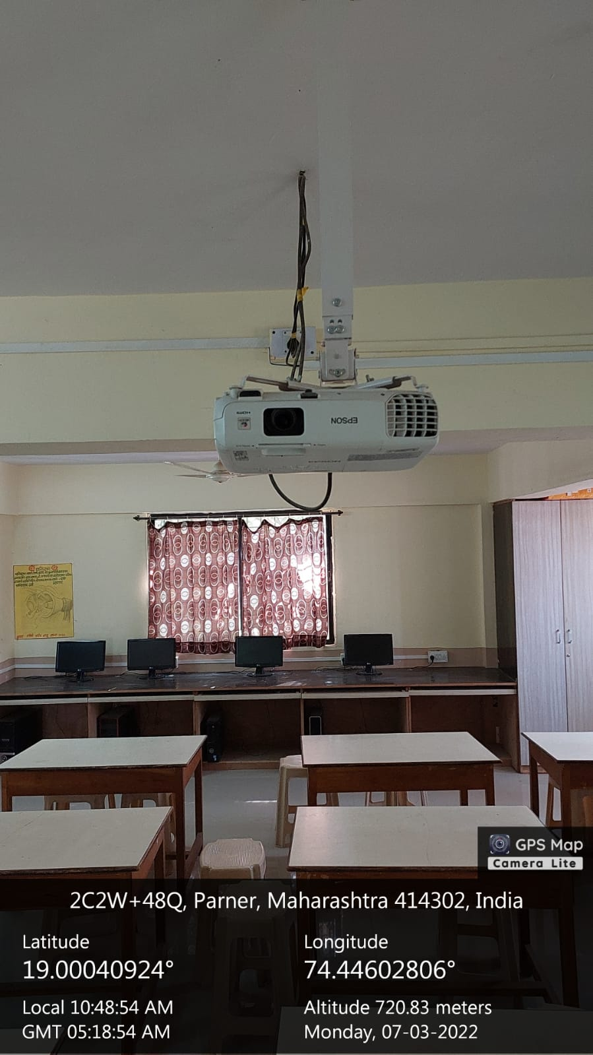 | 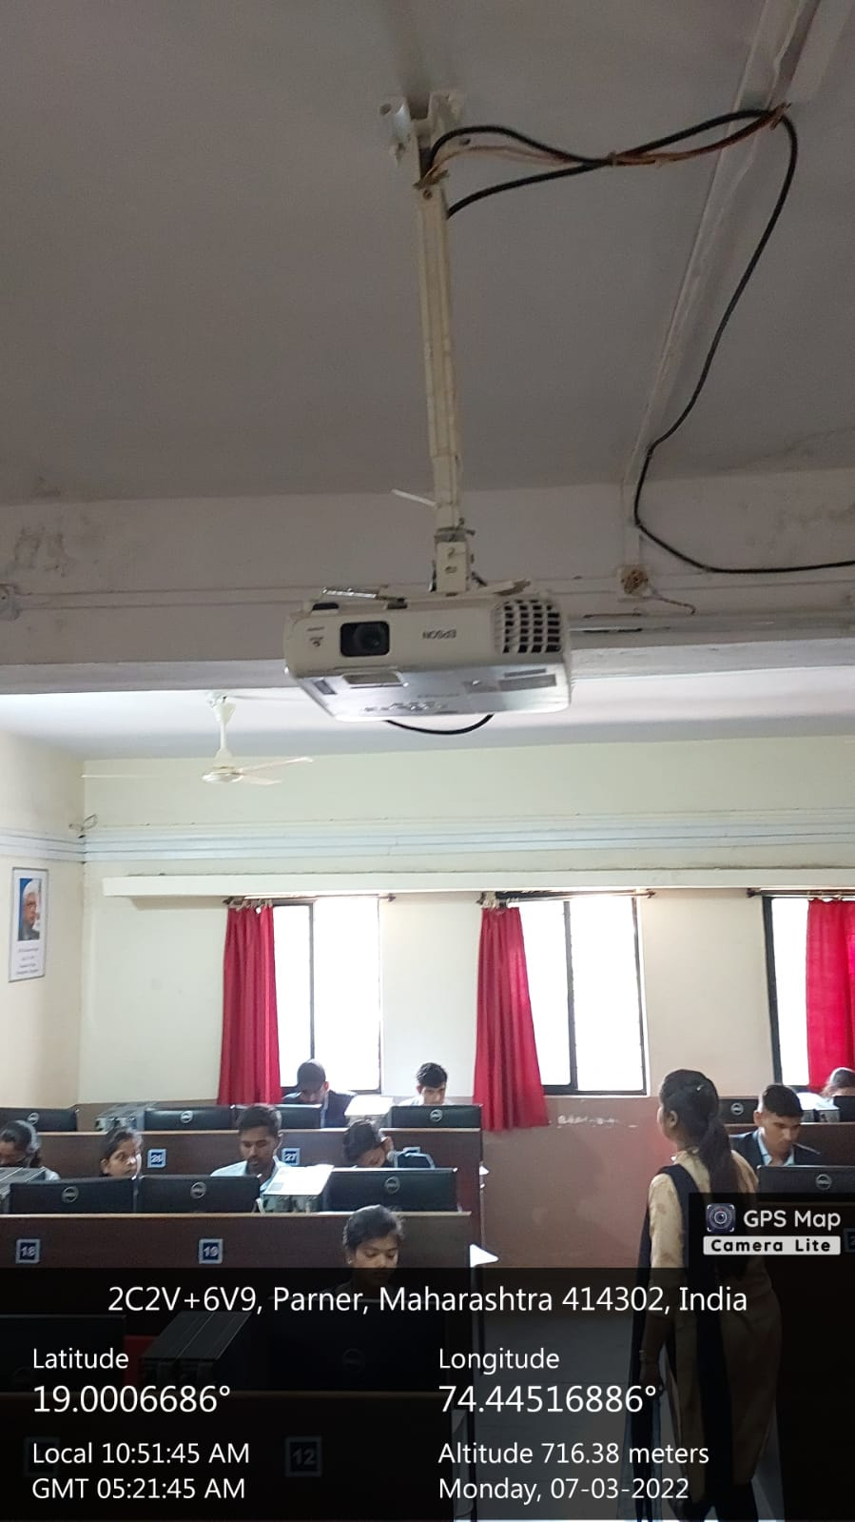
Arts & Com. Building Geo. PG Lab – II | Arts & Com. Building BBA-CA Comp. Lab
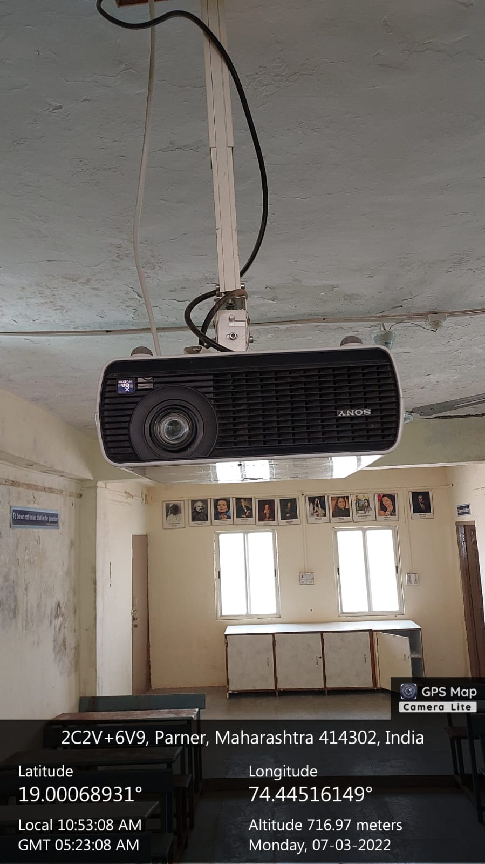 | 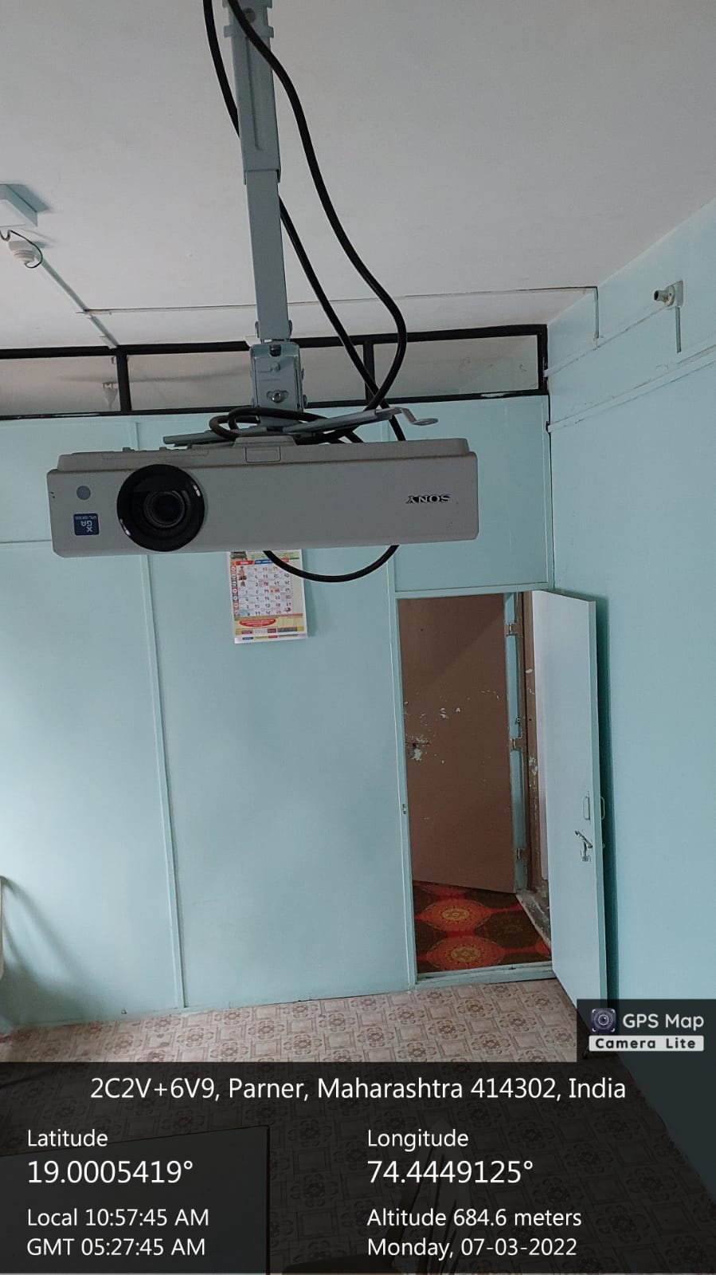
Arts & Com. Building English Department | Arts & Com. Building Library

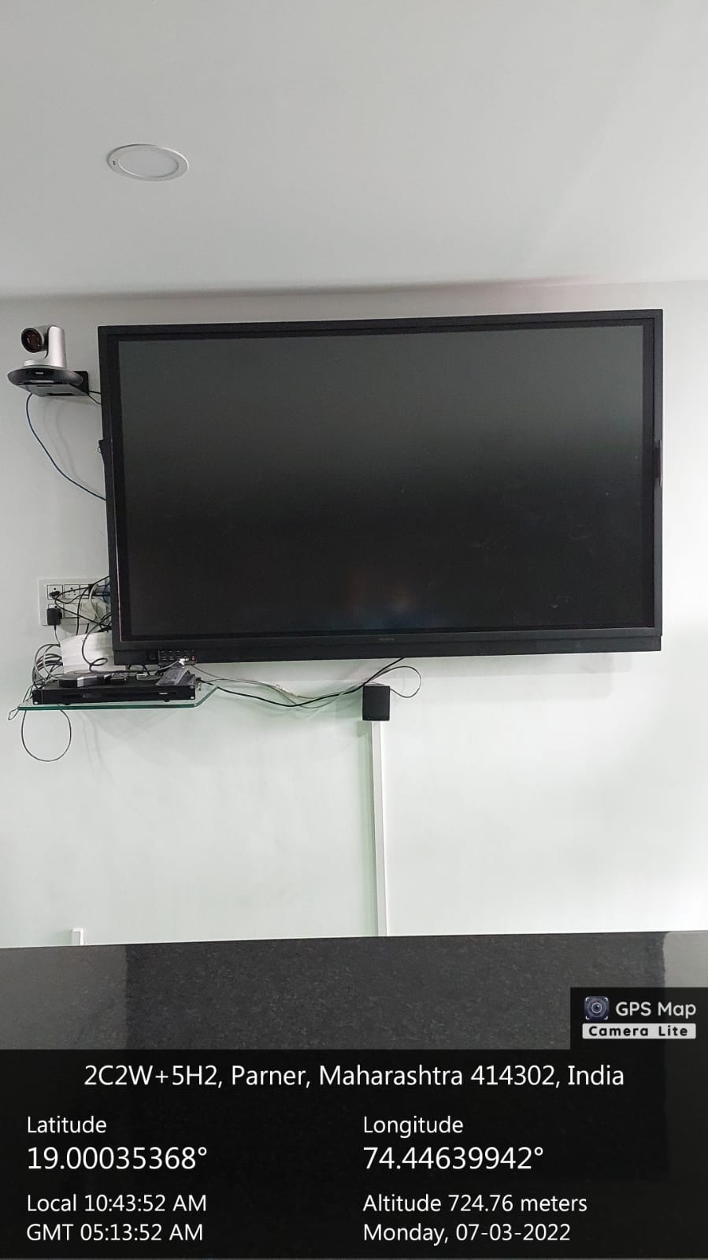
Administrative Building Virtual Classroom
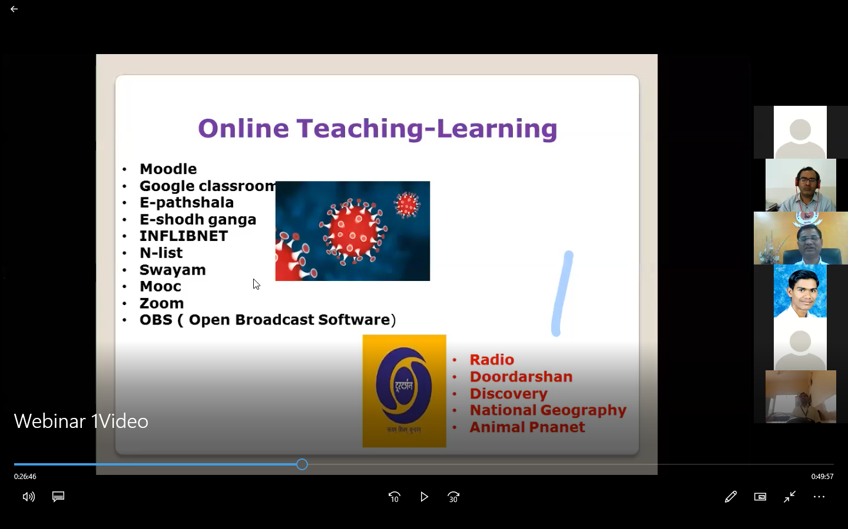 | 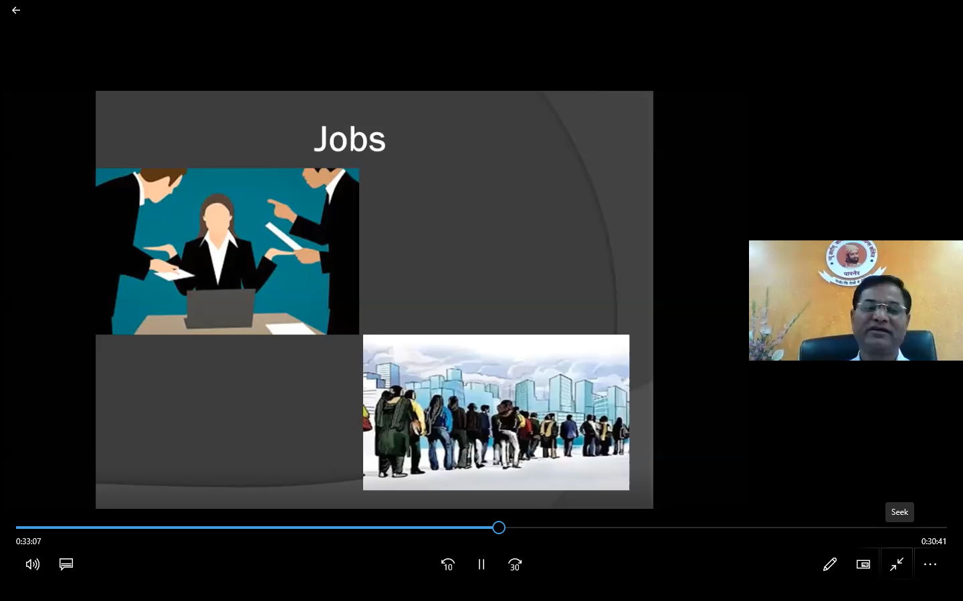
Online Teaching Learning Process

